EL is an inexpressive DL only allowing cojunctions n and ∃ as constructors.

Syntax of EL :
The main blocks of EL are Concepts and Roles
Concepts are unary predicates and roles are binary predicates. Expresses relationship between objects
Here we ignore constants, only use of variables

We consider infinite disjoint sets;
Nc for concept names such as female
Nr for role names such as haschild
Formally they are unbounded and infinite

Concepts are always represented as capital letters (A,B,C) where roles are in simple letters (r,s,t)

EL⊥ concepts are defined by (A € Nc (concept name), r € Nr(role name)
C :: = A | T | ⊥ | C ∏ C | ∃ r.C
C: class of all concepts concepts names, sometimes are called complex concepts to differentiate from concept names
Bars (|) separate different possibility
A: concept name
T: tautology (always true)
⊥ : contradiction
C: is a general concept, the two C can be different

There can exist the class of all concept names, tautologies and contradictions are concepts.

There can be the conjunction of two concept names C and there can be r as a role name and ∃ r.C is a concept
- Female is a concept
- T is a concept
- ∃ hasChild.Female (hasChild is a role name, Female is a concept, so ∃ hasChild.Female is a concert)
- Female ∏ ∃ hasChild.T it is a concept. Refers to the class that have a female class
- ∃ hasChild.Female ∏ ∃ hasChild.Male (Male is a concept, that total is a concept). Class of people that have one female and one male
- ∃ hasChild.(Female ∏ ∃ hasChild.Male) is a concept . People that have a child that is a female that have a male child. Have a daughter and that daughter have a son
- ∃hasChid.⊥ is a concept (it actually is a contraction) people that have a child that cannot exists

Semantics of EL :
An Intepretation is a pair I = (Δi, •i) where it is a non empty set of objects called the domain and the intepretation function which maps
Every A € Nc to a set Ai ⊆ Δ
Every r € Nr to a binary relation ri ⊆ Δi x Δi
Ti = Δi (T is tautology, implicitly we know that all objects satisfy top). The interpretation of top is the interpretation domain
⊥ i = ø no objects satisfy a contradiction. The interpretation of bottom (⊥) must be the empty set
(C ∏ D)i = Ci ∩ Di must satisfy C and D, must belong to both set so it must belong to the interception
( ∃ .r.C)i = {δ € Δi | ∃η € Ci. (δ, η) € ri}

Example :
Δi= {w,x,y,z}
Ai= (y,z)
Bi = (w,x,y)

ri = {(w,x), (x,x), (z,z)}
si = {(w, y), (x y) (z,z)}
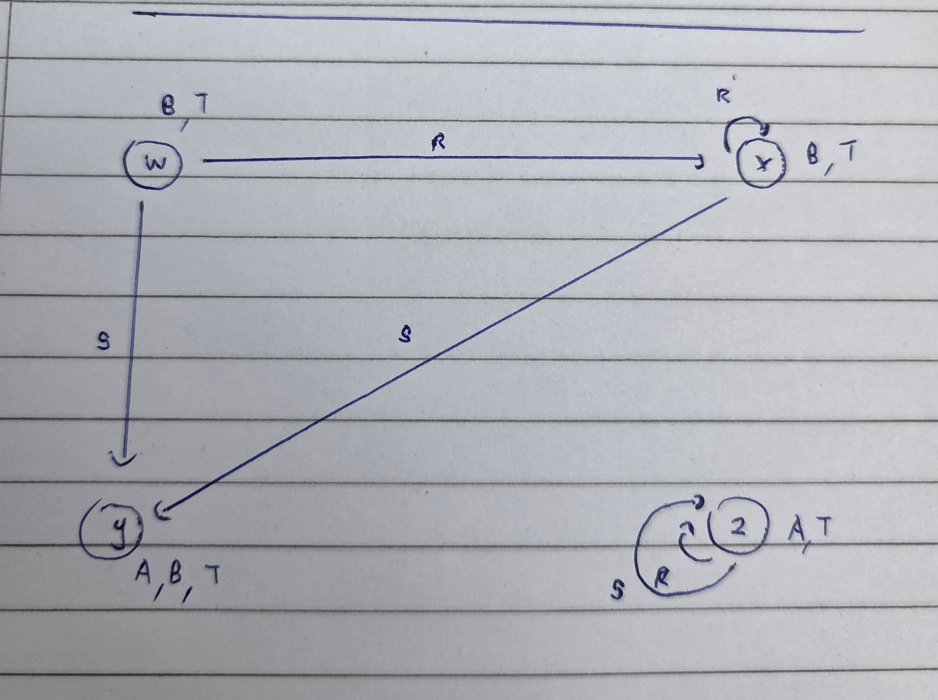
Note that for w and x we can say ∃ r.B given that the object belongs to B and has an r edge going to a B
We can say z ∃ s.A since they belong to a concept A and has an s edge going to A

C = ∃ r ∃ s.A means the concepts with an edge r that goes to ∃ s.A

Reasoning :
A concept C is Satisfiable if there is an interpretation I such that C set is a non empty set in the interpretation
Concept subsumption :
Let C and D be EL concepts
C is subsumed by D if for all intepretations I C is subsumed by D meaning C is a sub class of DWe will denote this as C ⊑ D
Concept trees :
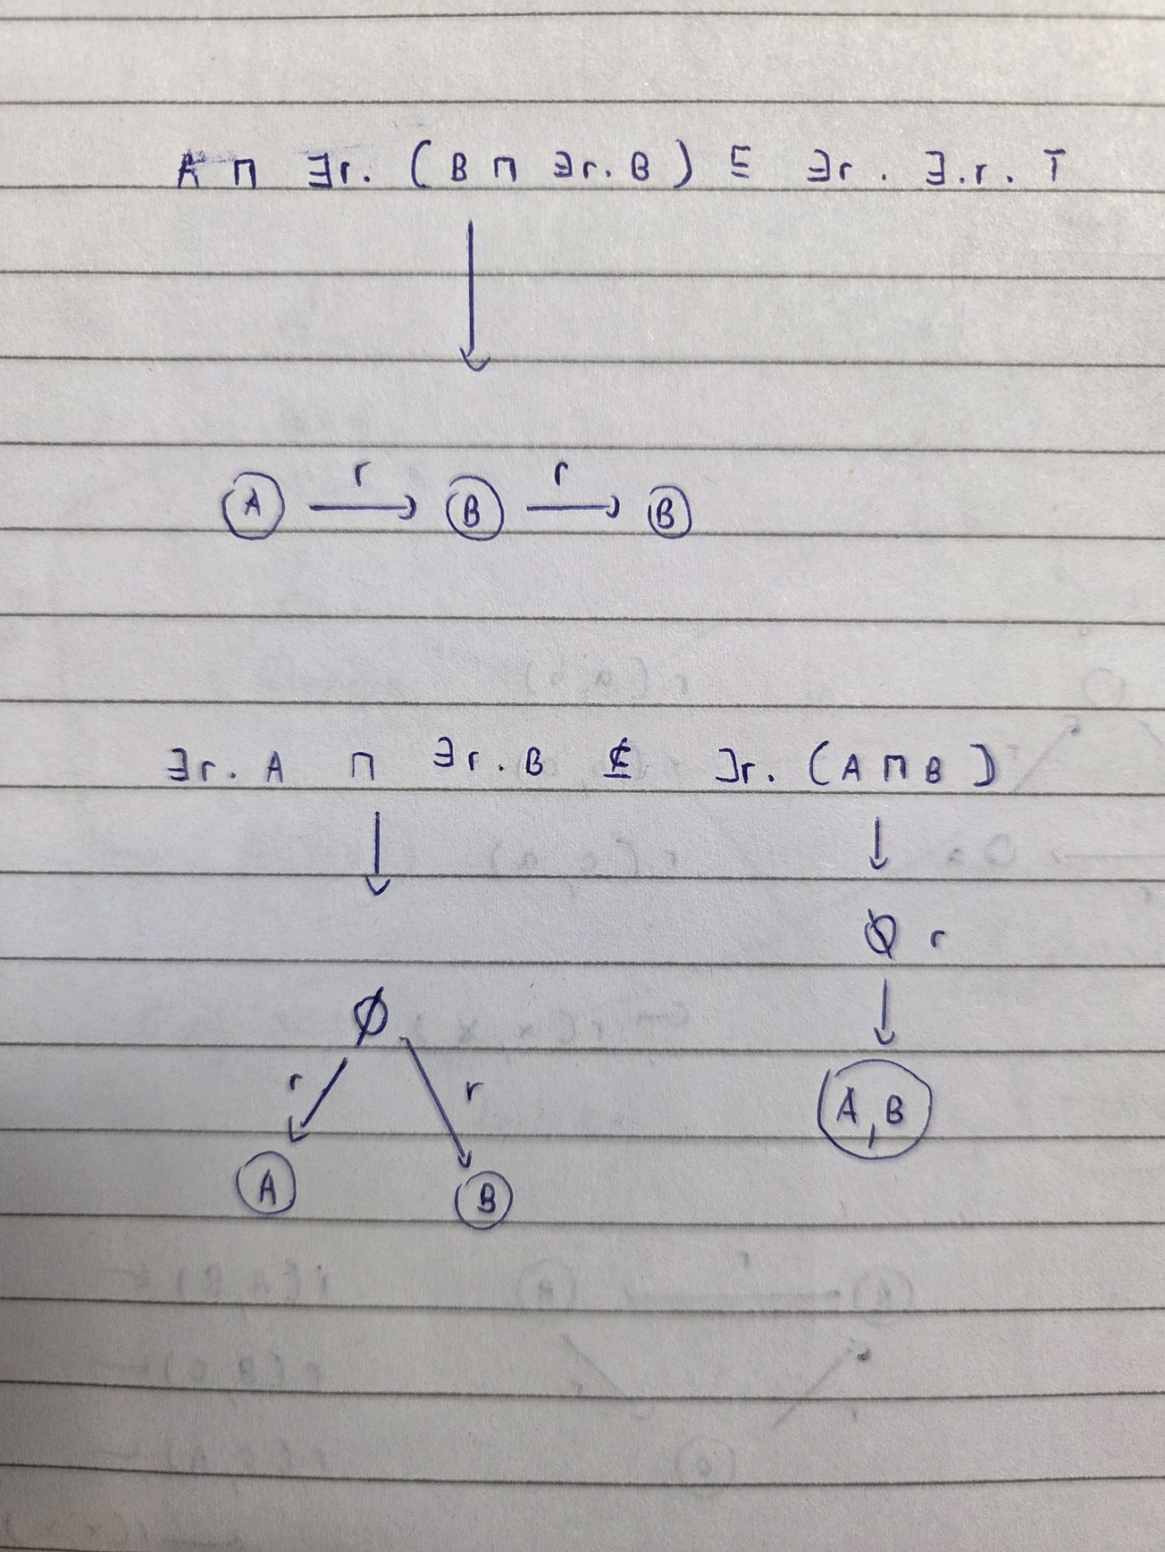
This is sort of a canonical model

Subsumption through homomorphism :
A Homomorphism between two concept trees T1 T2 is a function h mapping each node from T1 to T2
h(root(T1)=root(T2))
For every n € nodes(T1), label(n) ⊆ label(h(n))
If m is an r-successor of n, then h(m) is an r-successor of h(n)

Every element belongs to both trees
If the node is A then it needs to be mapped to at least A
If A was an r successor of B then it should be same for h(A) as an r successor of h(B)
Remember! C ⊑ D does not mean D ⊑ C

C is subsumed by D if we can find a homomorphism from T(D) to T(C)
All objects satisfying T(C) also satisfy T(D) thus all objects in Ci belong to Di. This is a subsumption
Ci ⊆ Di
C and D are equivalent if they are subsumed by each other in both directions
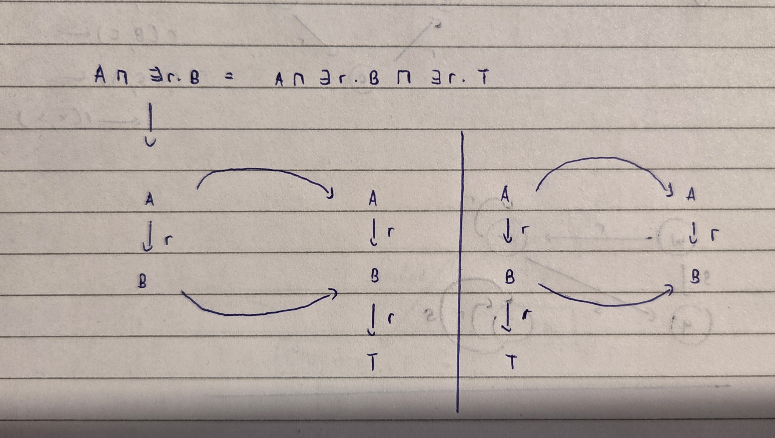

The terminological box (Tbox) :
The Tbox imposes restrictions to interpretation of concepts
Interpretations that do not satisfy this are ignored
A General concept inclusion GCI is an expression C ⊑ D
A Tbox is a finite set of these GCIs, implying a finite set of restrictions.

Tbox semantics :
An interpretation I satisfies the GCI C subsumed by D is Ci subsumes Di
I is a model of the Tbox if it satisfies all GCIs in Tbox T

Tbox reasoning :
Tbox reasoning is restricted to the class of models only
Concept satisfiability, if their exists a model I of T such that the set Ci is non empty
Concept subsumption (with respect to T) does Ci ⊆ Di hold for all models i of T

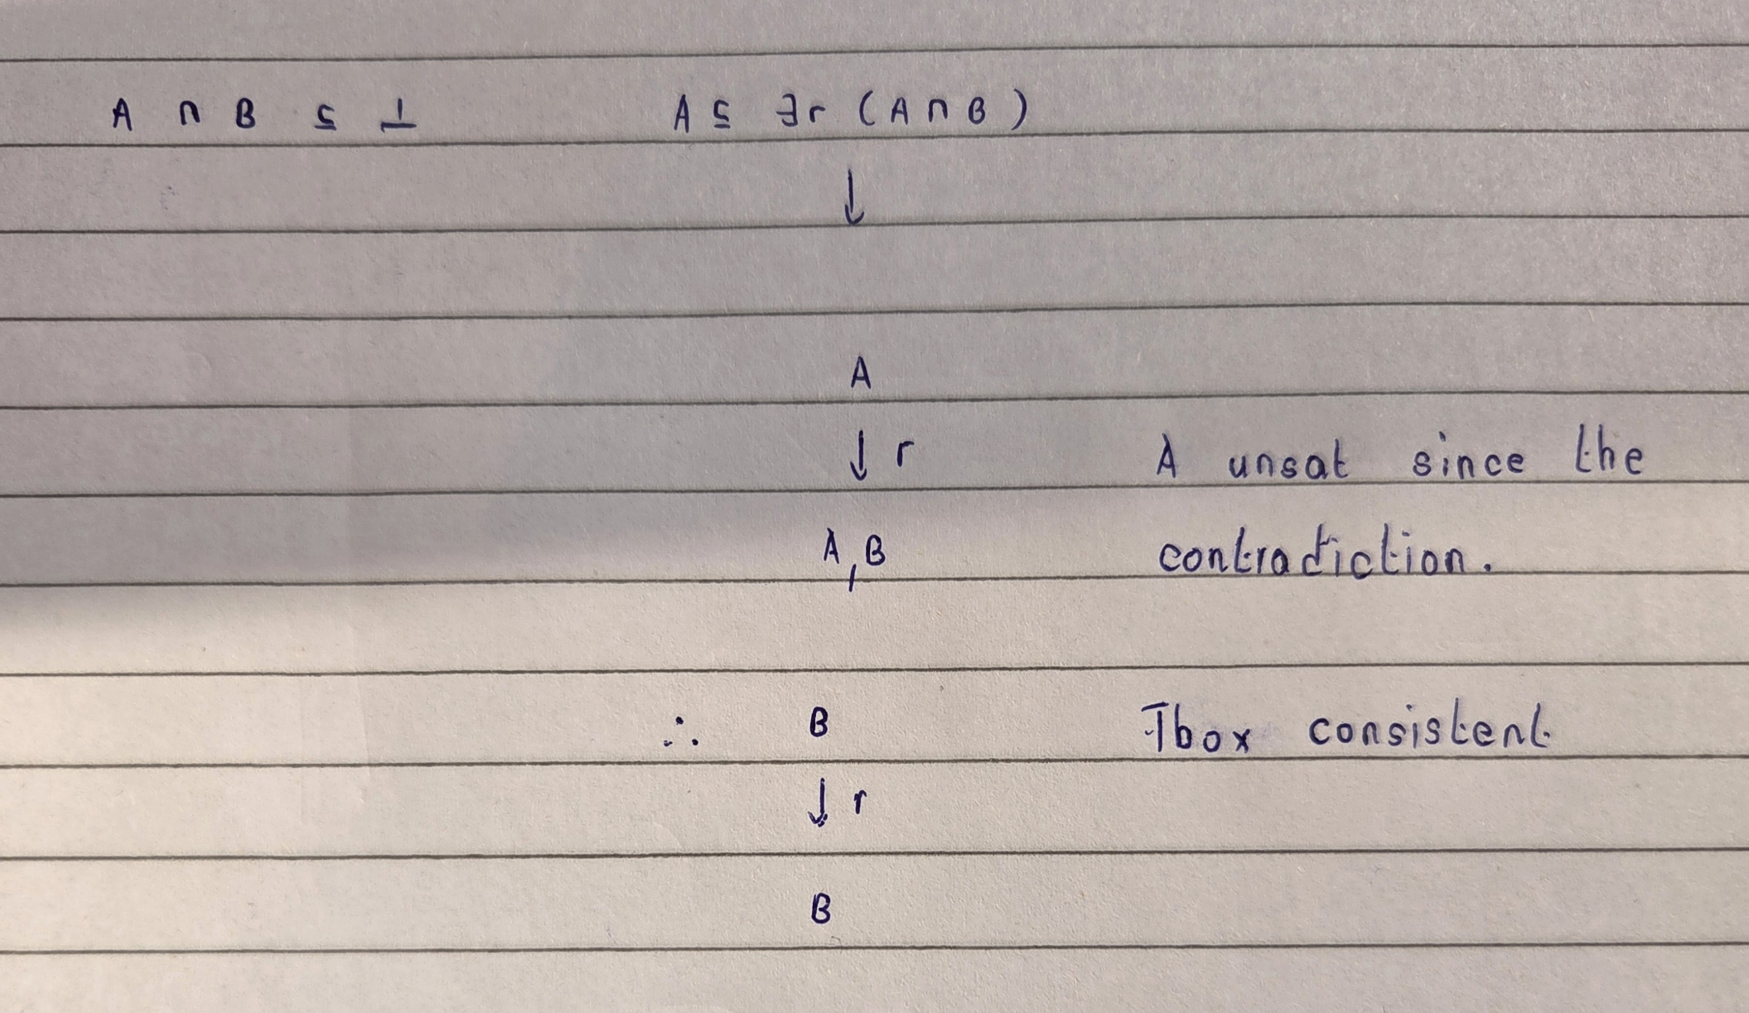
Note that every EL Tbox is consistent given that there are no contradictions. This results in that Every EL concept is satisfiable with respect to an EL Tbox
Normal form :
A GCI is in normal form if it has one of these shapes.
A ⊑ B
A1 ∏ A2 ⊑ B
A ⊑ ∃ r.B
∃r.A ⊑ B
Somewhat of an atomic syntax
A Tbox is in normal form if all the GCIs are in normal form
C ⊑ D ∏ E
Is equivalent to
C ⊑ D and C ⊑ E
Relationships with rules :
GCIs in normal are basically existential rules with constraints.

A ⊑ B B(x) ← A(x) if an object x belong to A it also belong to B
A1 ∏ A2 ⊑ B B(x) ← A1(x), A2(x)
∃ r. A ⊑ B B(x) ← r(x,y), a(y)
A ⊑ ∃ r.B SrB(x,y) ← A(x) r(x,y) ← SrB(x,y) B(y) ← SrB(x,y) three rules at the same time
T in body and ⊥ in the head are removed

Normalisation is not a restriction. Every finite set of GCI can be transformed into a Tboc in normal form.
C^ ⊑ D^ C^ ⊑ A A ⊑ D^
B ⊑ C ∏ D B ⊑ C B ⊑ D
∃ r.C^ ⊑ D ∃ r.A ⊑ D C^ ⊑ A
D ⊑ ∃ r.C^ D ⊑ ∃ r.A A ⊑ C^
B ∏ C^ ⊑ D B ∏ A ⊑ D C^ ⊑ A

If we sub something on the left side then it stays on the left side of the normalised subsumption and vice versa.
Norm T is the normalised T box we get. Normalisation never adds or removes subsumption relationships

1. If T ⊢ A ⊑ B and B ⊑ C € T then conclude T ⊢ A ⊑ C
2. If T ⊢ A ⊑ B1, If T ⊢ A ⊑ B2 and B1 ∏ B2 ⊑ C € T then conclude T ⊢ A ⊑ C
3. If T ⊢ A ⊑ B, If T ⊢ C ⊑ D and B ⊑ ∃ r.C € T then conclude T ⊢ A ⊑ ∃ r.D.
4. If T ⊢ A ⊑ ∃ r.B and ∃ r.B ⊑ C € T then conclude T ⊢ A ⊑ C
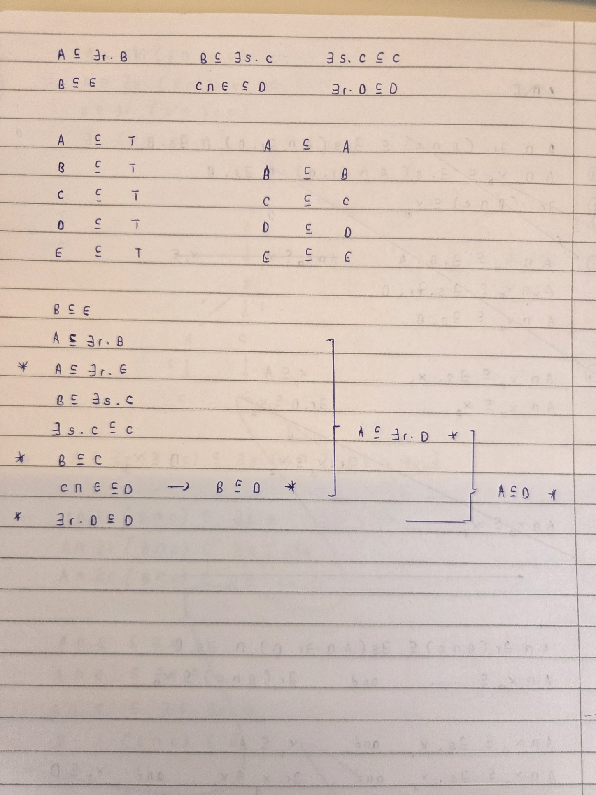
Soundness :
We need to show that every consequence derived is entailed by T
This depends on the soundness of the completion rules
Completeness :
We need too show that if a consequence is not derived then T does not entail it
We build a model that verifies this, find a model that does not satisfy it so we know its not true for any model
Model construction :
We first built the interpretation I
Δi = {δa | A € PC} (concept representatives)
Ai = {δB | B ⊑ A is derived}
ri = {δa, δb) | A ⊑ ∃ r.B is derived}

